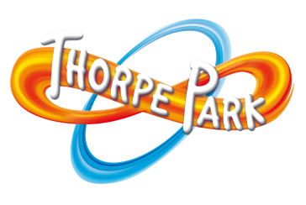

Year 7 Programme- Thorpe Park Rollercoaster Challenge

Time | Activity | Location | Delivery
8:45am – 8:55am | Introduction to Event | TBC
8:55am – 9:15am | Introduce rollercoaster challenge | TBC
9:15am – 9:35am | Marketing talk | TBC | Guest speaker
9:35am – 9:55am | Logo Quiz | Classrooms | Teachers
9:55am – 10:05am | Task 1 Name and Logos | Classrooms | Teachers
10:05am – 10:15am | Task 2 Design Ride | Classrooms | Teachers
10:15am – 10:30am | BREAK
10:30am – 10:40am | Complete Design | Classrooms | Teachers
10:40am – 10:45am | Job Roles | Classrooms | Teachers
10:45am – 11:50am | All Tasks | Classrooms | Teachers
11:50am – 12:00pm | Tidy up | Classrooms | Teachers
12:00pm – 12:45pm | LUNCH
12:45pm – 13:00pm | Prepare presentations | Classrooms | Teachers
13:00pm – 13:10pm | Evaluation forms | Classrooms | Teachers
13:10pm – 13:30pm | Presentations in Classrooms | Classrooms | Teachers
13:30pm – 14:15pm | Final Presentations**

** Final presentations will not take place as Year 7 will be completing NFER tests from 1.30pm onwards.

Teachers will complete judging sheets and winners will be announced after all 3 Enterprise days have been completed.

